**TASK 1**

**Objective: Programming**

* 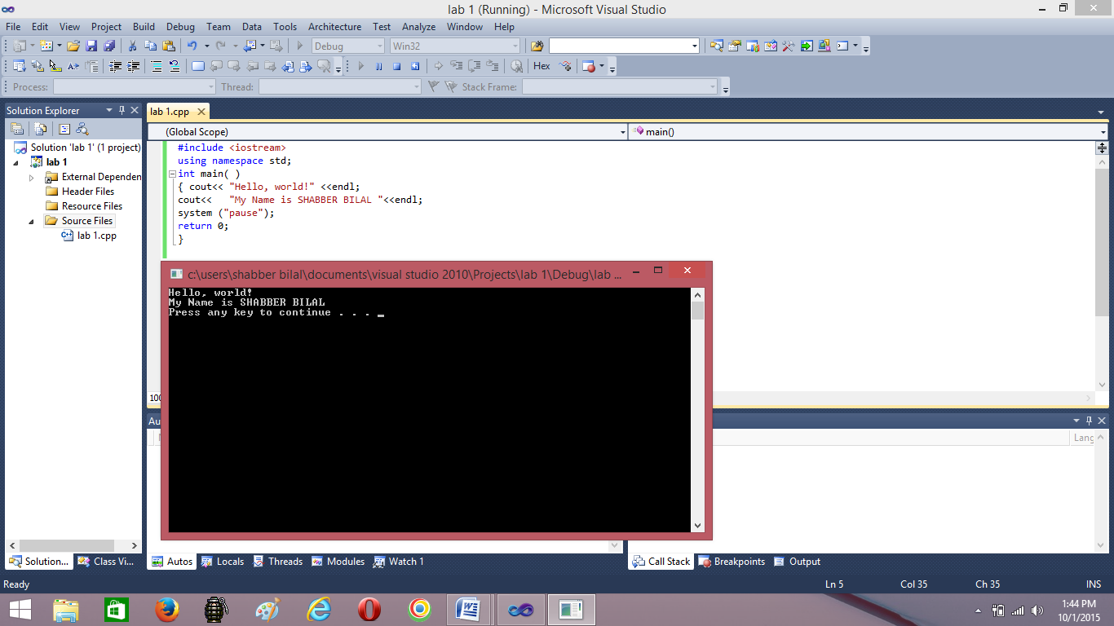Run C++ editor
* Type in the given program and execute it
* Observe the results

#include <iostream>

using namespace std;

int main( )

{ cout<< "Hello, world!" <<endl;

cout<< "My Name is ABC "<<endl;

return 0;}

**TASK 2**

**Objective: Programming**

* Type in the given code segment and try to compile it
* Inspect the compiling results
* Identify the errors
* Fix the program

#include <iostream>

using namespace std;

int main( )

{

cout<< "Hello, world!" <<endl

cout<< “ My Name is ABC <<endl;

return 0; }

**TASK 3**

**Objective: Programming**

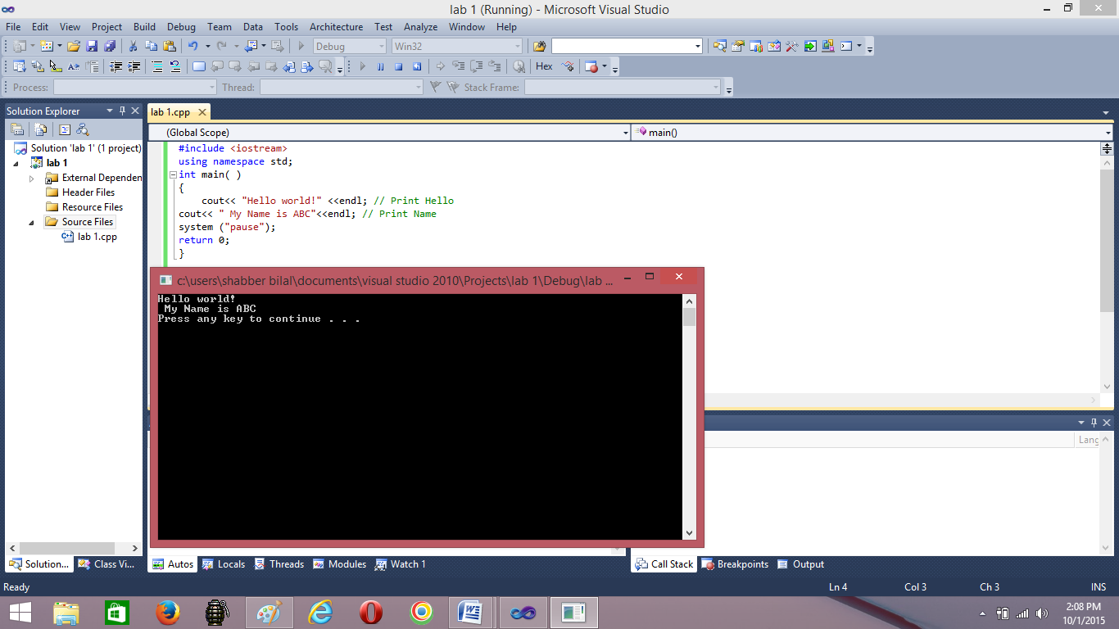Type given code segment and try to compile it

#include <iostream>

using namespace std;

int main( )

{

cout<< "Hello world!" <<endl; // Print Hello

cout<< " My Name is ABC"<<endl; // Print Name

return 0;}

**TASK 4**

**Objective: Programming**

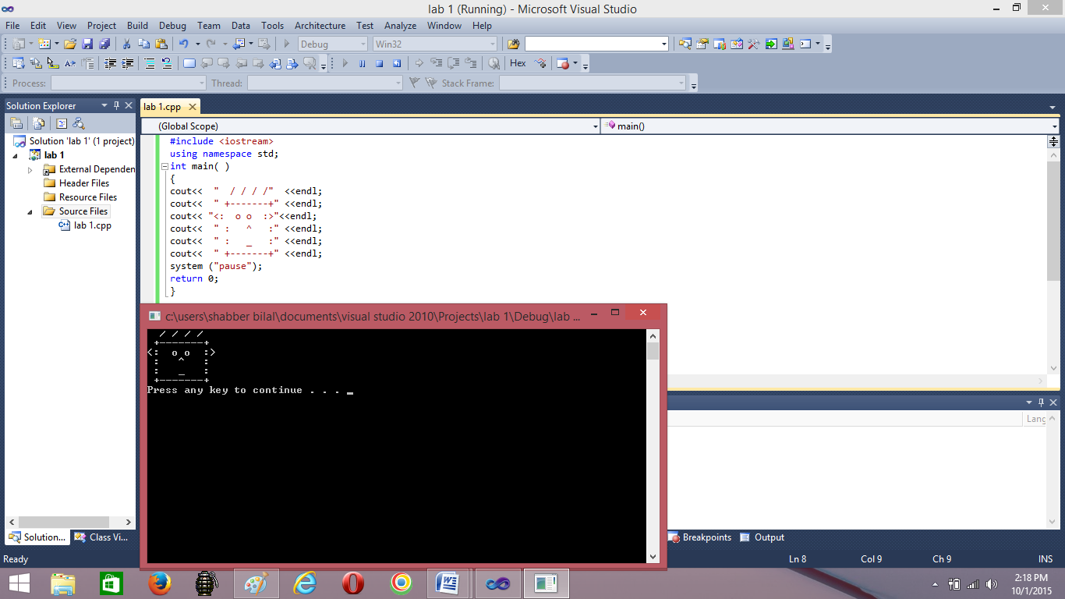Write a C++ program that displays a robot as below:

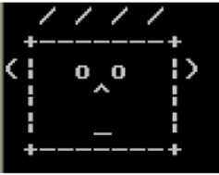

**TASK 5**

**Objective: Programming**

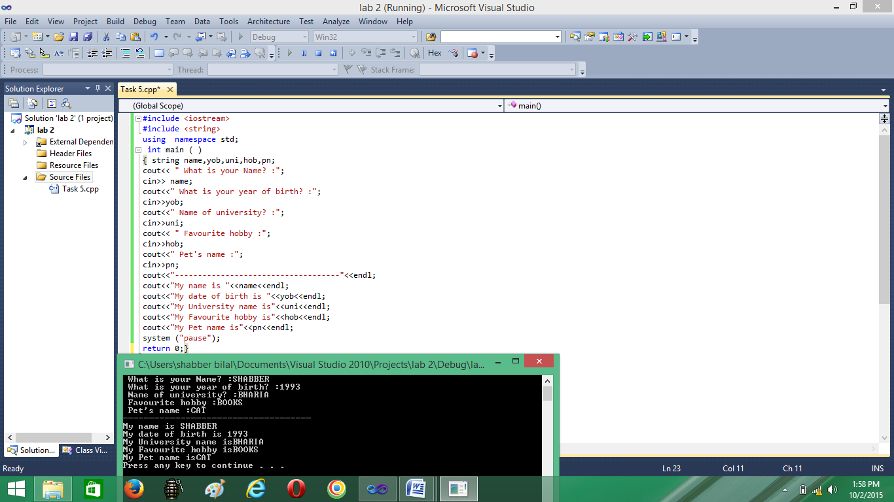Write a program that produces the following output:

**Output**

What is your Name? : Ahmed Ali

What is your year of birth? : 1993

Name of University: Bahria University

Favorite hobby: Reading

Pet’s name: Jasper